Connected JIRA Integration for frontend and backend with iterative prompting and got below results in UI
Backend integration prompt:

Read my entire workspace and understand the implementation of frontend and backend

I want to connect the backend implementation of "Connect Jira" button in UI.
Once the user enters the Base url,email id, Jira API key details in UI backend connection should be established based on these details and fetch the user story details
If the backend connection to JIRA is successful make the "Connect Jira" button as connected in UI
Display user stories in a dropdown in UI after fetching
Once the user selects a user story from the dropdown all the respective Story Title, Description and Acceptance criteria details should be populated in the UI

[STRICTLY] follow my instructions for backend and frontend connection

Read my entire workspace and understand how to resolve the error am getting for API integration with JIRA
Jira API error: 410 - {"errorMessages":["The requested API has been removed. Please migrate to the /rest/api/3/search/jql API. A full migration guideline is available at https://developer.atlassian.com/changelog/#CHANGE-2046"],"errors":{}}

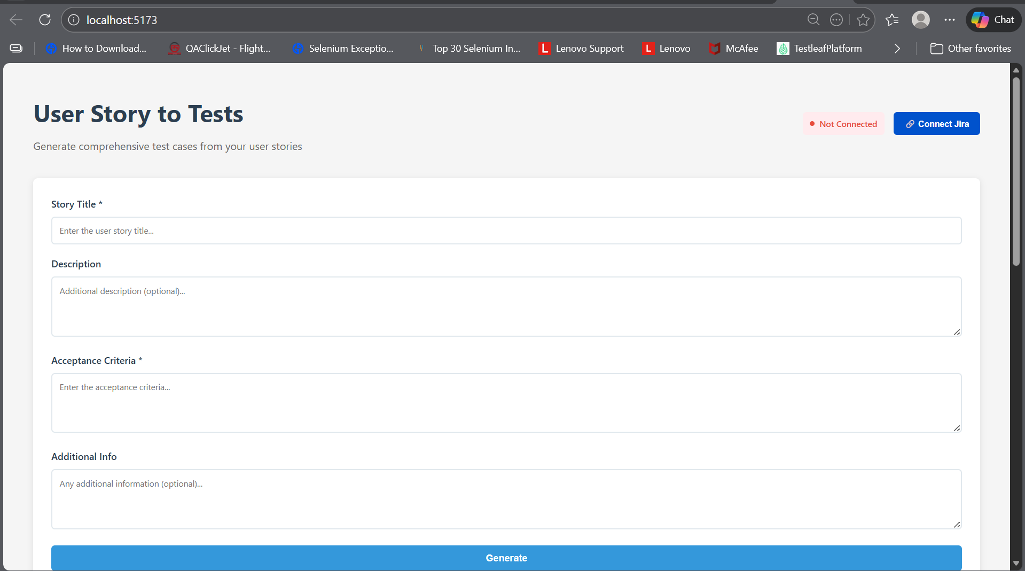
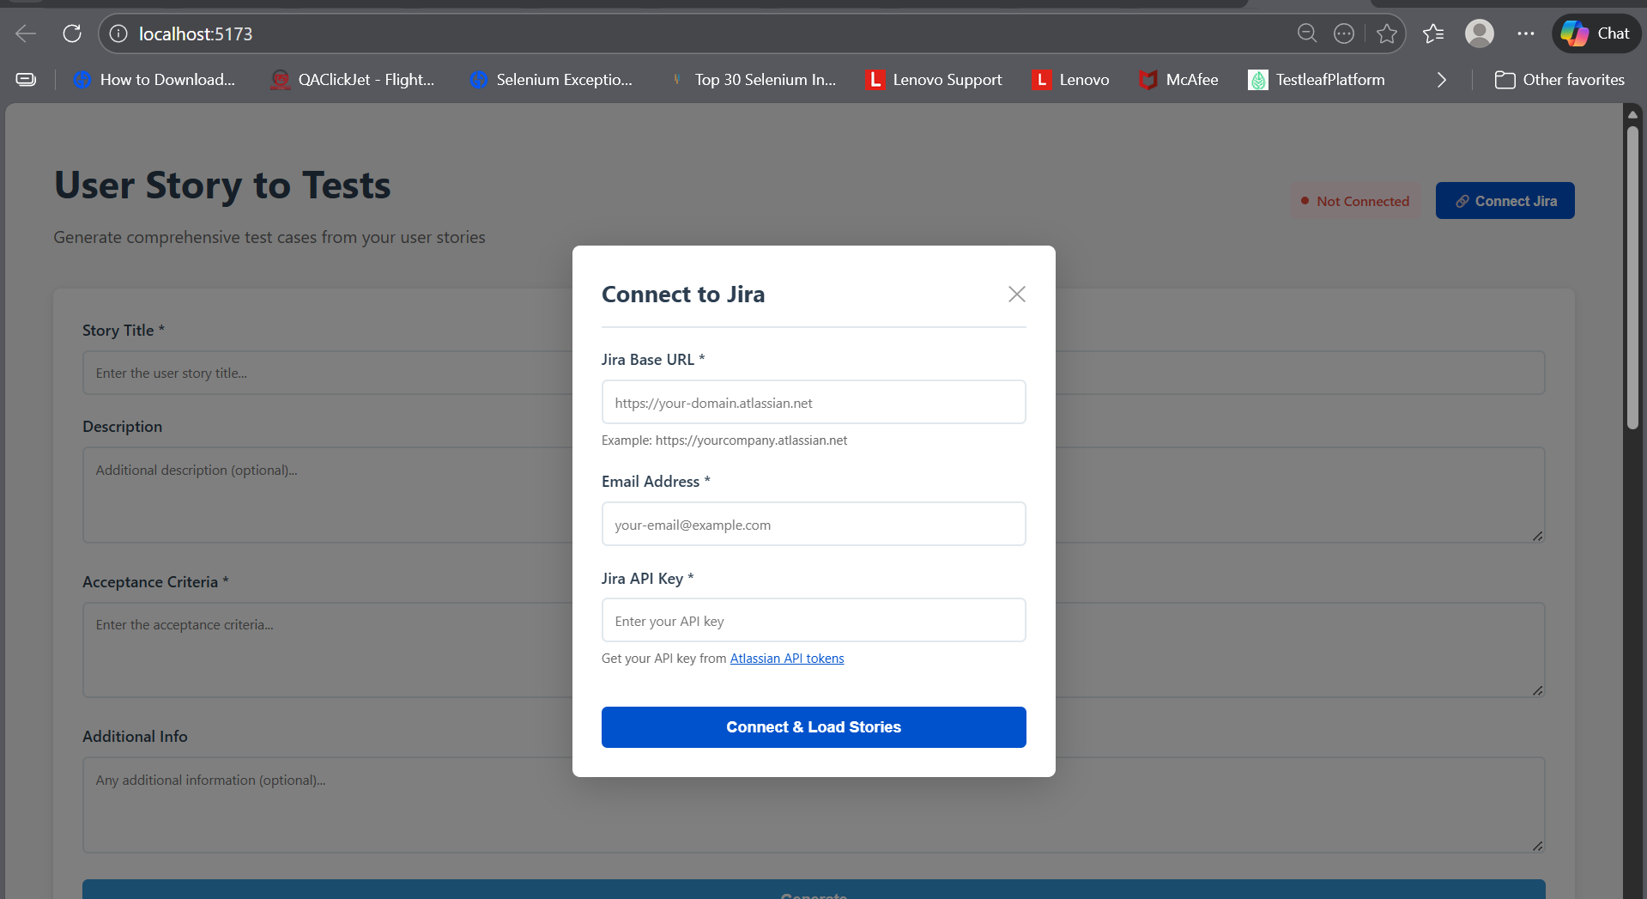
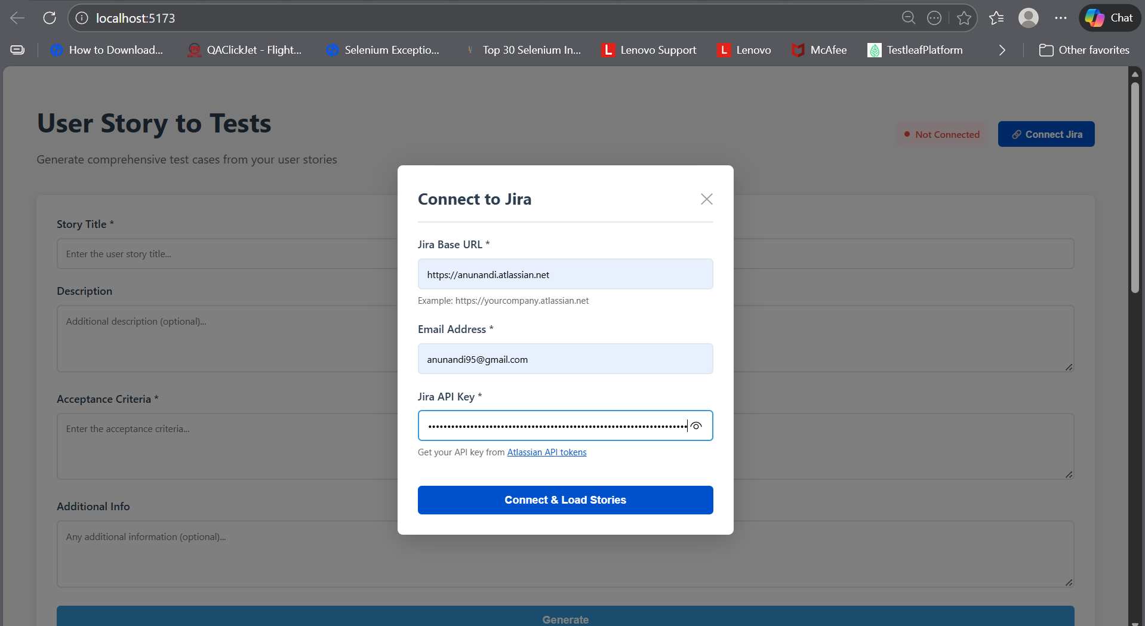
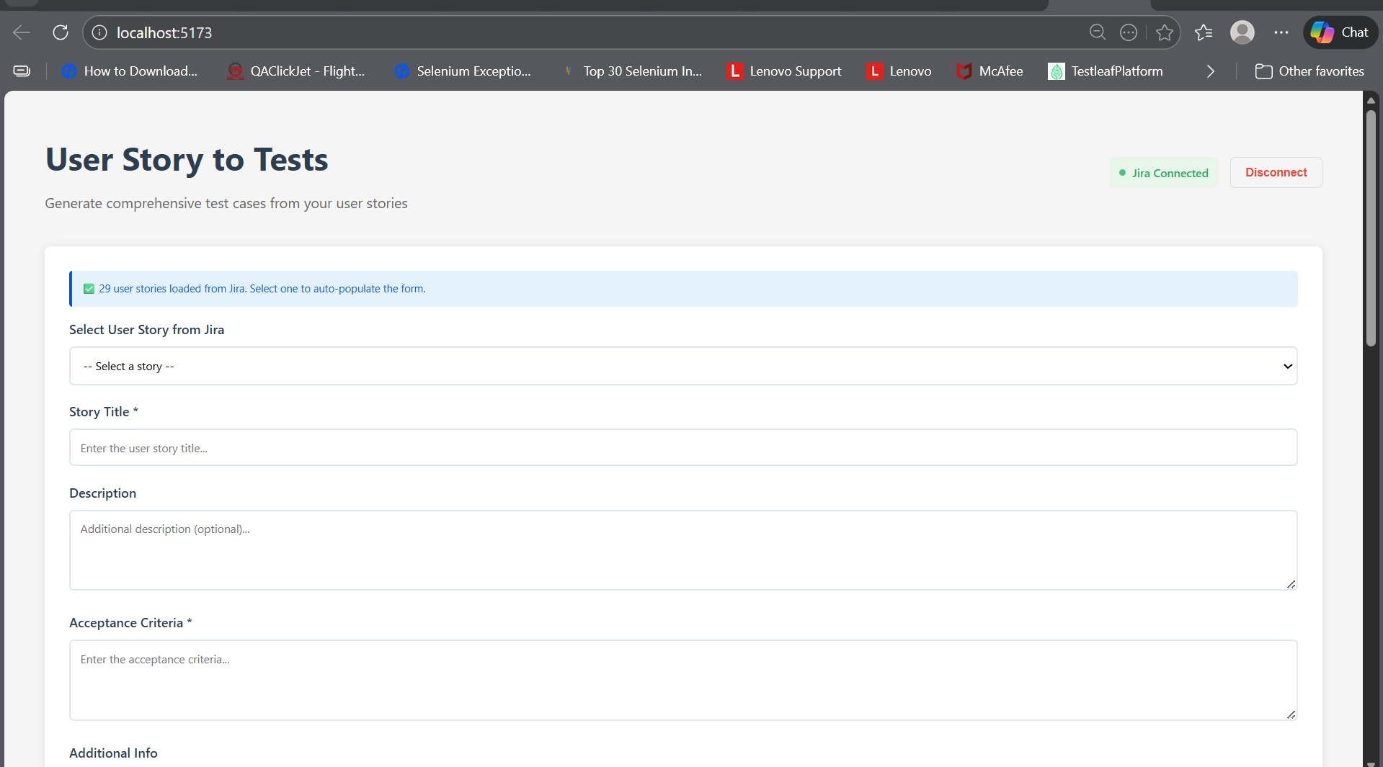
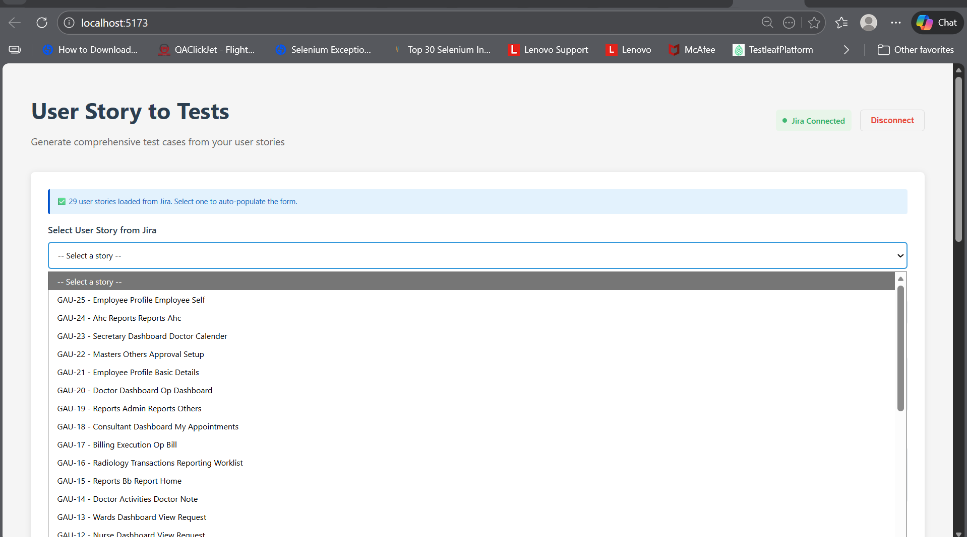
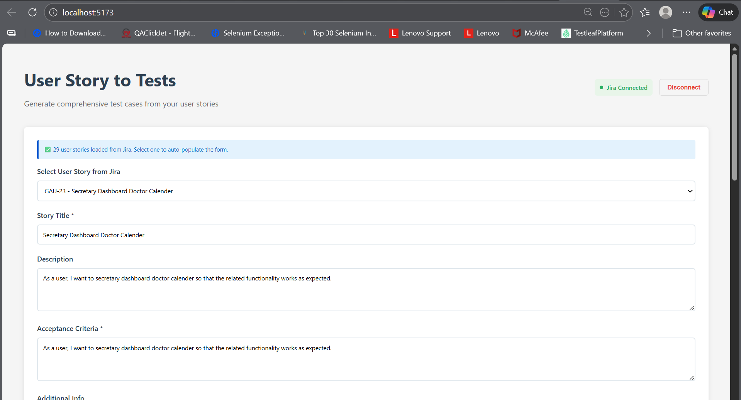
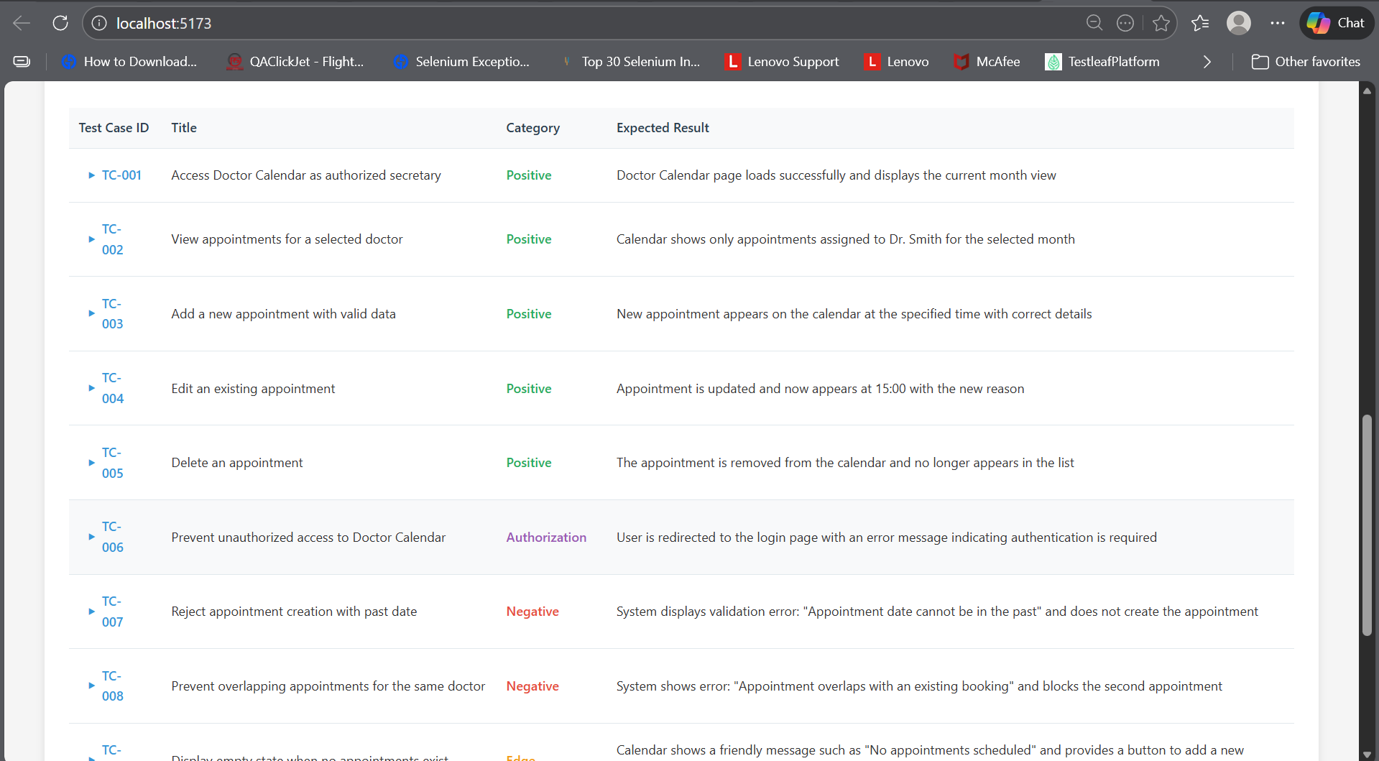
Adding Download options
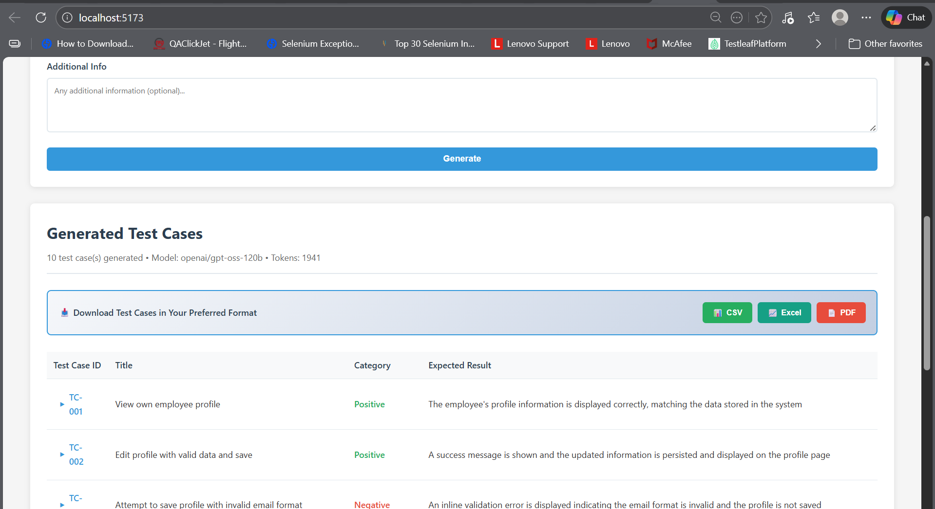
CSV:
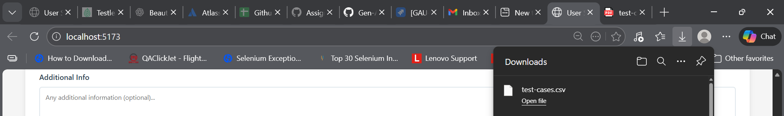
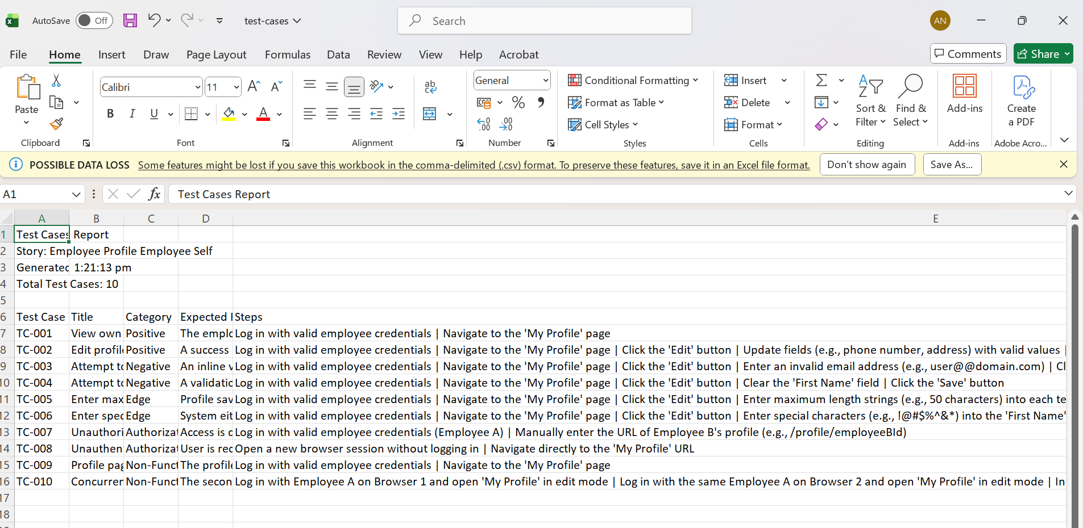

XLSX:
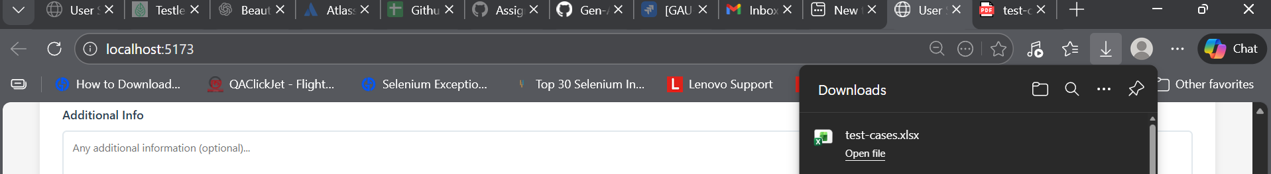
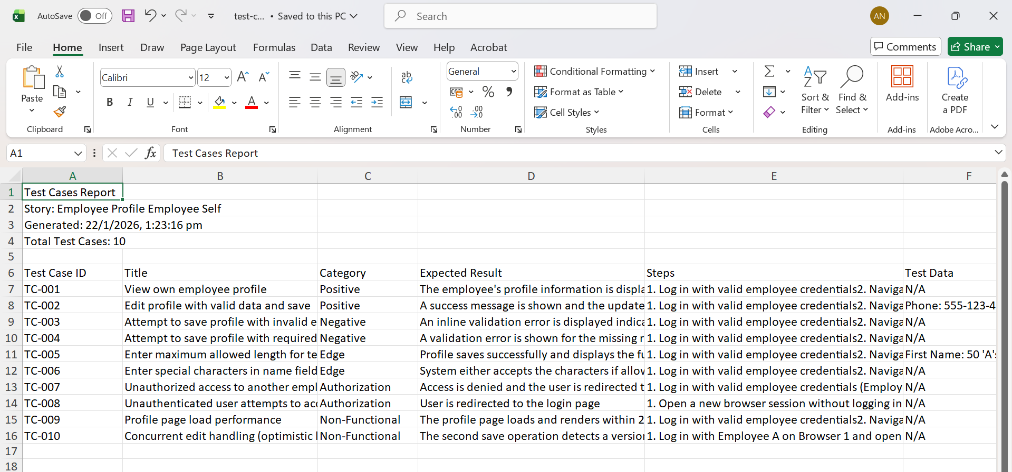

PDF:
